Dear

Planning and Environmental Management
West Offices
Station Rise
York
YO1 6GA

01904 552255

Typeface: Arial 14 point single spacing
Mr Peter Rollings
Rufforth and Knapton Parish Council
Bradley House
Bradley Lane
Rufforth
York
YO23 3QJ

4th March 2015
Dear Mr Rollings,

Rufforth and Knapton Neighbourhood Plan

I am writing with regard to your email and telephone messages about the Rufforth and Knapton Neighbourhood Plan.

I can confirm that we can commence publication of your Neighbourhood Plan application on 11th May, which will run until 22nd June 2015.

I believe that we have all the information needed to begin this first stage. Once publication has commenced, we will confirm the date of the Council decision session which will determine whether the application will be approved.

During the pre-election period, we would be happy to meet with you to discuss how we will support the process moving forward and to signpost key documents or studies which may be useful.

Please contact Rebecca Harrison who works in the Forward Planning team if you have any questions and to set up a meeting.

Yours Sincerely,

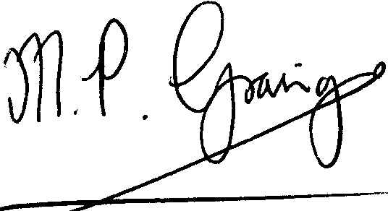
Martin Grainger
Head of Planning and Environmental Management

