PROPOSALS and ASSESSMENT OF POTENTIAL SITES FOR HOUSING
In assessing the suitability of potential sites for residential development the plan takes account of: -
- The national and local requirement for additional housing over the next twenty years
- The need to maintain the identity and style of the villages and the community spirit within the Parish
- The need (as identified by residents in our survey) particularly in Rufforth to encourage young families to the village in order to ensure the sustainability of facilities and services such as the Primary School, the village shop, the village hall and the Church.
- The importance (ranked highest of all in our survey) of protecting the Green belt and the open character of the countryside in the Parish and preventing the coalescence of communities and in particular maintain a Green barrier between Knapton and the City of York.
- Priority to be given to homes of 2 to 3 bedrooms suitable for young families or older people downsizing.
- Any development must have no adverse impact on an already stretched sewerage and drainage system.
- Suitable traffic access, with appropriate consideration for all health and safety issues, must be available and in the main existing roads and cul-de-sacs should be utilised.
- Design of housing must meet the standards set out in the village design policy.
- Sufficient off road parking to be provided.

Site 1 (see map below): The Plan supports the proposal for approximately 28 houses on this site at the end of Middlewood Close and on land extending behind the primary school and behind houses on the northern side of Middlewood Close subject to the following conditions:-
- Properties to be predominantly 2, 3 and small 4 bedroom houses
- Adequate off road parking or garaging to be provided thus obviating the need for residents parking on the roads
- A rear pedestrian entrance to the school to be provided to encourage parents to use this new access and thus alleviate the current parking pressure at school opening and closing times in Middlewood close and Yew Tree Close. New perimeter fencing will be required
- Access to be provided straight through the site for the new pig unit across the fields to the north
- Attenuation tanks for both sewerage and surface water to be constructed to ensure pressure on the existing system is not increased and hopefully reduced
- Covenants to be placed on properties to prevent further paving over of gardens

Site 2 (see map below): The plan supports proposals for nine properties on land at the end of Milestone Avenue, converting the existing track to a road which in turn would form the site boundary, subject to the following:-
- Properties to consist of 3 terraced cottages, 2 three bedroom detached houses and 4 bungalows
- Adequate off road parking and/or garaging to be provided for the detached houses and bungalows and approx. 9 parking spaces to be provided to cater for the cottages and visitors.
- Suitable measures to be taken to ensure that the development adds no further pressure to the sewerage and drainage system either by the construction of attenuation tanks or other proven engineered solution
- Covenants to be placed on properties to prevent the further paving over of gardens
The landowner has agreed to lease land to the Parish Council to enable the construction of a footpath/ cycle path linking the end of Milestone Avenue with the existing cycle path around Harewood Whin
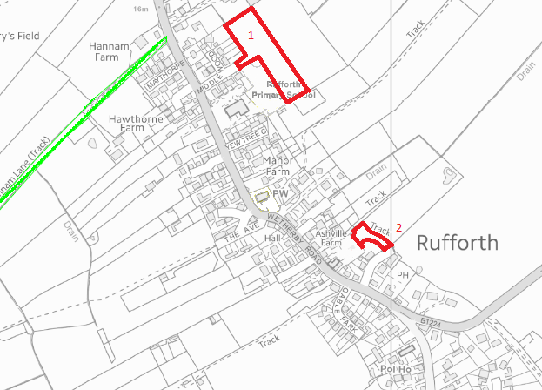

In Knapton the Plan would support very limited in-fill development within the village envelope as defined in the Plan. Any proposals outside this village envelope are considered inappropriate as they would be on protected green belt land and any development here would result in the coalescence of Knapton with the City of York, due to its already close proximity. The Green Belt not only preserves the rural character of the village of Knapton but also the character and outlook of the historic City of York. A planning application has already been submitted for land at the junction of Main Street and Back Lane. At the time of writing no decision has been made on this application and we await the result before making any proposals.

There is a willing landowner for housing on a site known as Wheatlands. This is on land bordering the A59 and the Trenchard Road area of the Parish and is on the boundary and shared by Upper Poppleton Parish and Rufforth with Knapton Parish. The site was proposed in the City of York draft local Plan [2014] but is opposed by both Parish Councils concerned.
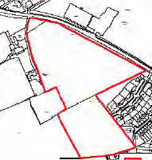
Wheatlands is grade two agricultural land in the green belt and as such should be protected for the purpose of food production. Whilst not strictly a planning matter food production is recognised by Government as of strategic importance to the United Kingdom and accounts for the employment of some 5% of the population. Grade two is rated as very good land and if built on is lost to food production for ever.
Both primary and secondary schools in the area are already over-subscribed. GP practices in the area are also struggling to cope with a high number of patients, with limited capacity to increase. Traffic congestion is an existing problem on the A59 Boroughbridge Road and onto the ring road. Proposals for sites ST1 and ST2 will result in approximately 1200 dwellings, potentially adding 2000 cars. This has to be viewed in conjunction with this proposed development.

Proposals were considered for a site for approximately 80 homes on land adjacent to the Chapelfields area of York. This site is on Green belt land which has the primary purpose of preventing the outward urban sprawl of the City of York and contributes significantly to the openness of the area. It is considered that any agreement to build here would create a precedent and potentially allow future development up to the ring road boundary. However, of the potential sites in the Green belt it is the least damaging in terms of outlook and access to services and if City of York requires additional land to the West of the City to meet housing requirements we may be prepared to reconsider this site subject to very strong safeguards against any other Green belt development in the Parish.
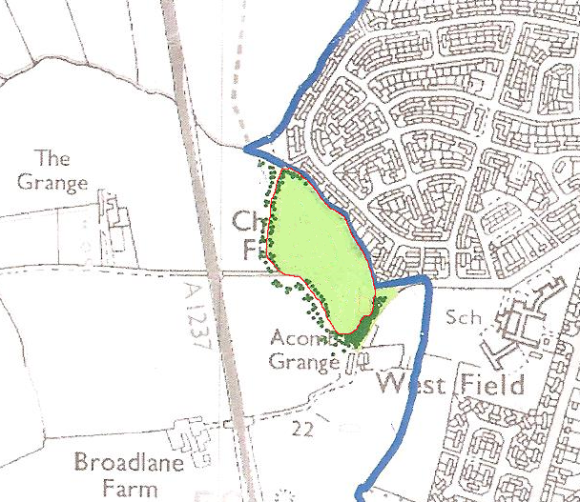
A site along Bradley Lane adjacent to Southfield Close was put forward but was rejected as being outside the Rufforth village envelope and adjacent to the Gliding Club runway.

In summary the plan proposes, allowing for some infill, the building of some 40 additional homes over the period of the Plan with the majority of these being 2, 3 and small 4 bedroom houses suitable for young families. This represents an increase of around 10% in the total households in the Parish thus making a sensible contribution to local and national housing needs and to the sustainability of services and facilities in the Parish.

