Site Reference: RK E1
Site Name: Northminster Business Park
Site size: 2.5ha
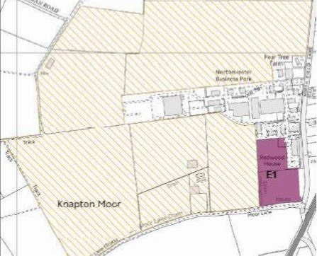

Site Allocation Approach Description:
It is proposed that 2.5ha of land be allocated to meet employment uses over the plan period. Further land to the west and north of site E1 is proposed to be left as greenfield Land.
It appears that the site may actually be 2 fields, in which case the top half should be utilised, allowing the bottom half to act as a green buffer away from Knapton and the bridle path.

Site Allocation Approach Justification:
Development on the site would need to provide a suitable site access, ideally via Hackness Road and sustainable transport approach.
The site would require appropriate screening, as Knapton and the A1237 are part of the green infrastructure corridor around the City of York. Current high trees / hedging would serve this purpose.
It will be important to ensure that the roofline does not protrude above the appropriate screening, again to prevent a negative impact on the green area.
Care would need to be taken when planning unit type, to ensure there isn’t a detrimental impact on congestion accessing to the site. Types identified – B1b (business use for high technology), B1c (light industry), B2 general industry, B8 warehouses.

